
Tribhuvan University
Institute of Science and Technology

A Final Year Project Report
(CSC412 Project Work)
On
E MAT
“Electronic Management and Administrative Tool”
Submitted to:
Department of Computer Science and Information Technology
Mahendra Multiple Campus
Nepalgunj, Banke

In partial fulfillment of the requirements for the Bachelor of Science in Computer Science and Information Technology (BSc CSIT)

Submitted by:
Ashim Poudel (Symbol No:30344/078)
Shirish Adhikari (Symbol No:30370/078)
Taraman K.C (Symbol No:30375/078)
Under the supervision of
Keshav Poudel
August,2025
Tribhuvan University
Institute of Science and Technology
Mahendra Multiple Campus

Nepalgunj, Banke

Supervisor’s Recommendation

I hereby recommend that the project report titled “E-MAT: Electronic Management and Administrative Tool,” prepared under my supervision by Ashim Poudel (Batch 2078, TU Registration No.5-2-55-22-2021, Symbol No.30344/078) and Shirish Adhikari (Batch 2078, TU Registration No.5-2-55-47-2021, Symbol No.30370/078) and Taraman K.C(Batch 2078, T.U Registration No.5-2-55-52-2021, Symbol No.30375/078), is satisfactory. It fulfills the partial requirements for the degree of Bachelor of Science in Computer Science and Information Technology (BSc CSIT) and is recommended for final evaluation.
……………………..
Keshav Poudel
Supervisor
Assistant Professor
Mahendra Multiple Campus, Nepalgunj

Tribhuvan University
Institute of Science and Technology
Mahendra Multiple Campus
Nepalgunj, Banke


Letter of Approval
This is to certify that the project work (CSC412) entitled “E-MAT: Electronic Management and Administrative Tool”, prepared by Ashim Poudel (Symbol No:30344/078) and Shirish Adhikari (Symbol No:30370/078) and Taraman K.C (Symbol No:30375/078), has been completed in partial fulfillment of the requirements for the degree of Bachelor of Science in Computer Science and Information Technology (BSc CSIT) under the Institute of Science and Technology, Tribhuvan University. The project has been evaluated, and in our opinion, it meets the required scope and quality standards for the degree.

……………………..
Keshav Poudel
Supervisor

……………………..
Internal Examiner

……………………..
Madan Kumar Adhikari
Program Coordinator
Department of Computer Science and Information Technology

……………………..
External Examiner

Acknowledgment
We express our sincere gratitude to Mahendra Multiple Campus, Nepalgunj for their invaluable resources and consistent support throughout our project. The college's commitment to academic excellence has significantly influenced our educational journey, and we appreciate the tools and guidance provided.
A special acknowledgement goes to Mr. Keshav Paudel for his exceptional guidance and support throughout the project. His knowledge and prompt assistance have played an important role in the success of our work. We extend our thanks to all other supervisors for their contributions to the project.
Furthermore, we would like to thank our classmates for their encouragement and collaborative efforts in creating a supportive environment that facilitated the growth of this project.

Members:
Ashim Paudel (Symbol No: 30344/078)
Shirish Adhikari (Symbol No:30370/078)
Taraman K.C (Symbol No:30375/078)

Abstract
E-MAT is a secure and user-focused digital voting platform designed to modernize the election process in Nepal. The system allows registered voters to log in using their unique Voter ID and cast their votes online. It ensures a convenient and transparent voting experience. It eliminates the need for physical presence, manual vote counting, and paper ballots, significantly reducing human error and administrative burden.
The platform supports real-time vote tracking, candidate management, and result publication. Admins can create and manage elections, add candidates, and verify voter eligibility. With features like one-vote-per-user validation and encryption-based vote storage, E-MAT prioritizes security, integrity, and accessibility.
The aim of this project is to digitally transform traditional elections by providing a reliable, accessible, and tamper-proof system that encourages voter participation and builds trust in the democratic process.
Keywords: Election System, Online voting, Automatic Results, Secure etc.

Table of Contents
Supervisor’s Recommendation ii
Letter of Approval iii
Acknowledgment iv
Abstract v
Table of Contents vi
List of Figures viii
List of Tables ix
List of Abbreviations x
1.Introduction 1
1.1 Background 1
1.2 Problem Statement 1
1.3 Objectives 2
1.4 Scope and Limitations 2
1.5 Development Methodology 3
1.6 Report Organization 4
2.Literature Review 6
2.1 Background Study 6
2.2 Literature Review 6
3.System Analysis 8
3.1 System Analysis 8
3.1.1 Requirement Analysis 8
3.1.2 Feasibility Analysis 11
3.1.3 Analysis 13
4.System Design 16
4.1 Design 16
4.1.1 Component Diagram 16
4.1.2 State Diagram 17
4.1.3 Sequence Diagram 17
4.1.4 Wireframe Diagram 18
4.2 Description of Algorithms 21
5.Implementation and Testing 23
5.1 Implementation 23
5.1.1 Implementation Tools 23
5.1.2 Implementation Details of Modules 23
5.2 Testing 24
5.2.1 Test Cases for Unit Testing 24
5.2.2 Test Cases for System Testing 25
5.3 Result Analysis 26
6.Conclusion and Future Recommendations 27
6.1 Conclusion 27
6.2 Future Recommendation 27
References 28
Appendix 29

List of Figures
Figure 1.1:Prototyping Model 4
Figure 2.1:Use case diagram 8
Figure 3.1:Gantt Chart for work schedule 13
Figure 3.2:Class diagram for the E-MAT system 14
Figure 3.3:Activity diagram for the E-MAT system 15
Figure 4.1:Component diagram of the E-MAT system 16
Figure 4.2:State diagram of the E-MAT system 17
Figure 4.3:Sequence diagram of the E-MAT system 18
Figure 4.4:Interface for Homepage 19
Figure 4.5:Interface for Admin Login 19
Figure 4.6:Interface for Voter Register 20
Figure 4.7:Interface for Admin Dashboard 20

List of Tables
Table 3.1:Use case Description 9
Table 5.1:Test case for Admin Login 24
Table 5.2:Test case for Voter Login 25
Table 5.3:Test case for Casting Vote 25
Table 5.4:Test case for Register and Login Workflow 26
Table 5.5:Test case for Casting Vote and Viewing Result 26
Table 5.6:Test case for Admin Election Control 26

List of Abbreviations
API Application Programming Interface
CASE Computer Aided Software Engineering
CSS Cascading Style Sheets
CV Curriculum Vitae
E-MAT Electronic Management and Administrative Tool
E-voting Electronic voting
HTML Hypertext Markup Language
ID Identity Document
MMC Mahendra Multiple Campus
NEA Nepal Engineer`s Association
OTP One Time Password
UI User Interface

1.Introduction

1.1 Background
E-MAT is a system where people can vote using computers in web-based Application. It is faster, safer, and more accurate than the old paper-based voting system. E-voting helps reduce mistakes, saves time, and makes the voting process clearer and fairer.
In Nepal, people mostly use the traditional way of voting, but many now want a better and more secure method. Problems like cheating, recounts, and long delays can be solved using an online voting system. As more people in Nepal use the internet and become familiar with technology, online voting can help improve the way elections are done.
The E-MAT project is a website that allows people to vote online. It is designed to be simple, safe, and easy to use. Voters can register, log in, and vote from anywhere. Admins (election managers) can also use it to manage the election, check the voting progress, and see results immediately.
The system is built using the React with typescript, Tailwind CSS as frontend and Python as backend which is a modern set of tools used to make fast and responsive websites.
E-MAT can be used in schools, offices, or even for local government elections. It makes voting easier, safer, and faster for everyone.
In short, E-MAT is a useful online voting system that can help us to move toward digital and fair and elections

1.2 Problem Statement
In Nepal, many institutions still use manual voting systems, which often cause problems, delays, and disagreements. Manual paper-based voting takes a lot of time and can easily have mistaken, cheating, and lack of clarity. These problems reduce the trust and truthfulness of elections in schools and organizations.
Also, because there is no central and safe voting system, it is hard to manage voter details, check who is allowed to vote, and make sure each person votes only once. Counting votes by hand takes time and can cause errors, which causes delays in giving results and makes voters unhappy.
There is a growing need for a modern electronic voting system that makes elections easier, clearer, and allows more people to take part. Without such a system, people may lose interest in voting and feel left out of the democratic process.
E-MAT, the suggested online voting system, can solve these problems by giving a safe, automatic, and easy way to hold elections fairly and clearly.

1.3 Objectives
This project aims to secure, make transparent, and institutionalize the election process of institutions, organizations, and other concerned agencies in Nepal. By a digital election process.
The key objectives of the E-MAT project are as follows:
- To provide a online platform to conduct elections in a secure and transparent manner.
- To ensure one-person-one-vote integrity via one method of voter identification.
- To automate the vote counting and give real-time results to prevent delays.

1.4 Scope and Limitations
The scope of the E-MAT project is to create a secure and transparent online voting system that allows voters to register, cast their votes, and view results digitally, while helping administrators manage elections easily and efficiently.
The project scope in E-MAT project includes:
- The system will be deployed as a web application that provides the users with a facility to vote on the platform securely from any internet-connected device.
- The system will have two major user roles: Admin and Voter. The admins will maintain the elections, voters' lists, and results. Voters can see the information of the elections and vote securely.
- The system will automatically count votes and generate real-time results, improving accuracy and eliminating time wastage.
The limitations of the E-MAT project is that it needs a device to vote, may be hard for non-tech users, and is best suited for small elections. It is only developed for the small elections in organizations.
Here are the some of the limitations of the E-MAT project:
- The system is only available through a web browser, with no native Android or iOS mobile applications developed.
- The system only supports the English language, with no other language support.
- The system does not incorporate biometric verification, limiting the degree of voter identity validation in comparison to advanced e-voting systems.

1.5 Development Methodology
For our project E-MAT, the evolutionary Prototyping model is used as it allows us to develop our work in a repeatable manner, allowing us to continuously improve. Each new version of the prototype brings new and improved features and functionality. The prototyping model methodology involves building an initial prototype with basic functionality. This model helps to visualize the representation of the final product. By collecting feedback from clients and users, identifying potential improvements and addressing any issues or concerns. Based on the feedback, further iterations of the model will be developed, including additional features, enhancements to the user interface. This iterative process ensures that the final product meets the needs and expectations of our users and allows flexibility throughout the development process.[1]
The figure below represents the stages of evolutionary prototyping model. It begins with requirement gathering to understand what is needed. These requirements are then analyzed to determine feasibility and how they should be implemented. Based on this analysis, an initial prototype is developed. The client evaluates this prototype, providing feedback on its performance and features. Suggestions for improvement are collected during this evaluation phase and are fed back into the prototype development, signifying an iterative process. Improvements are made, and the prototype is refined over multiple iterations, continually involving client feedback until it meets the client’s expectations. Once the prototype is sufficiently evolved, the design phase formalizes the structure of the final product. The design is then transformed into a working system through the coding stage. After coding, integration testing ensures all parts of the software work together correctly. Finally, the software enters the maintenance stage, where it is updated and fine-tuned while being in use to accommodate any additional requirements or changes that arise over time.
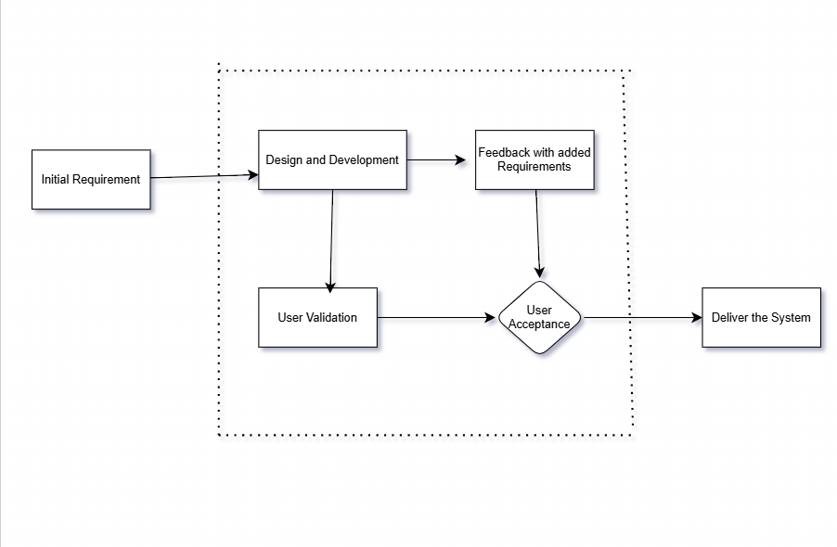
Figure 1.1: Prototyping Model

1.6 Report Organization
Chapter 1 provides an overview of the project, introducing its significance and addressing the identified problem. The chapter outlines the objectives, defines the scope and limitations, presents the chosen development methodology, and provides an overview of the report organization.
Chapter 2 the background study includes fundamental theories, concepts, and terminologies related to the project. The literature review offers a comprehensive overview of similar or relevant projects, theories, and findings by other researchers, establishing a context for the project.
Chapter 3 focuses on system analysis, exploring in-depth requirements through functional and non-functional aspects. It includes a feasibility analysis covering technical, operational, economic, and schedule aspects. and modeling techniques like class and activity diagrams are detailed in the analysis section.
Chapter 4 moves to the design phase. The chapter also discusses user interface design and provides detailed insights into the algorithmic aspects of the project.
Chapter 5 includes the practical aspects of the project. It describes the tools used in the implementation phase, including CASE tools, programming languages, and database platforms. The chapter provides implementation details for modules, classes, procedures, functions, methods, and algorithms. Testing is covered extensively, with details on unit testing, system testing, and result analysis.
Chapter 6 draws conclusions based on the findings and outcomes of the project. It also outlines potential future recommendations for further enhancements or expansions of the project, bringing the report to a comprehensive close.

2.Literature Review

2.1 Background Study
The old-fashioned voting system, such as paper ballots and count by hand, has been in existence for decades. While prevalent, the systems are much criticized for being laborious, inefficient, subject to human error, and susceptible to tampering. As the world becomes ever more digital, the desire for a clearer and safer voting system has become an important issue, especially in democratic bodies, educational institutions, and private institutions.
Electronic voting systems, or e-voting systems, have emerged as a future solution to overcome these limitations. The systems enable individuals to vote via safe channels electronically. E-voting reduces the chances of duplicate votes, counting errors by humans, and tampering. E-voting also simplifies the voting process, speeds up the generation of results, and enhances accessibility for voters, especially in remote areas.
Different pilot tests and experiments all over the world have shown that electronic voting systems, when implemented with strong authentication and encryption procedures, can achieve the highest voter participation and trust in the election process. Estonia, for instance, is a front runner in national digital voting, with online voting since 2005 backed by strong digital proof of identity. These deployments provide good lessons regarding the role digital platforms can play in strengthening election integrity.
In Nepal, e-voting is in its infancy, mostly limited to experimental or institutional use. With growing digital literacy and internet penetration, however, the potential for effective, transparent, and secure voting systems becomes more pertinent. Organizations like universities, student unions, and associations can largely gain the benefits of using e-voting systems like E-MAT, enabling quick, fair, and easy elections.

2.2 Literature Review
In the context of the E-MAT project, it focuses on understanding digital voting systems, their design, security measures as password hashing and the technologies used to ensure fair and transparent elections. It examines the key concepts of online voting, including voter authentication, data encryption, secure vote storage, and result verification. Some of the existing digital or web-based election systems utilized or tested across the world or locally include:
Elector, a mobile-based e-voting prototype developed using Flutter. It allows users to vote through their smartphones with features like end-to-end encryption, secure login, and user verification.[2].
E-nirwachan, an academic project using Django that offers biometric-based e-voting. It verifies users through facial and fingerprint recognition before allowing them to vote, focusing on secure and authenticated digital elections.[3].
NEA’s voting system, an electronic voting system used in its internal elections. The system allows secure member verification and vote casting and is an example of real-world digital voting implementation within a limited scope.[4]

3.System Analysis

3.1 System Analysis
The analysis of the various requirements of the system and the possibilities of actually creating the system is the main theme of this section.

3.1.1 Requirement Analysis
Both the functional and non-functional requirements of the E-MAT system are described below:

I. Functional Requirements
It defines how the users interact with the system. Some of the functional requirements in this project are how admin, voter, and system interact with each other as seen in this use case diagram
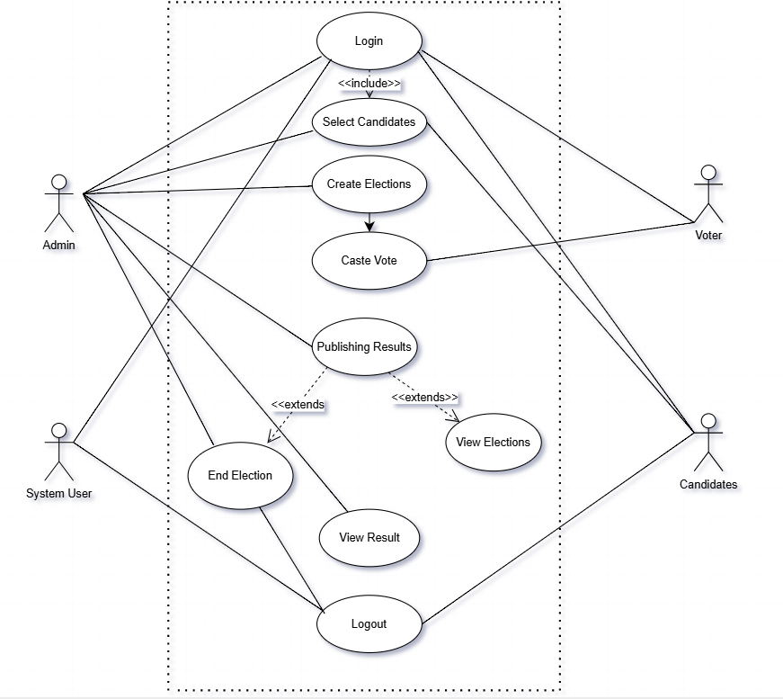
Figure 2.1: Use case diagram for the system
User Roles:
1.Voter / User:
- Create and update a personal user profile.
- Log in securely with unique credentials or voter ID.
- See ongoing elections and related information (upcoming elections, timeline, rules).
- Submit a single, secure vote for a specified candidate.
- Receive confirmation on successful casting of vote.
- Receive reminders of upcoming elections, deadlines, and results.
- See published results after the election process has ended.
2.Admin:
- Log in securely into the admin console.
- Create, edit, and manage elections (set start and end time, add candidates, etc.).
- Manage and verify the list of registered voters.
- Monitor the voting process and tracking participation.
- Publish results automatically once voting is complete.
- Send important updates or instructions to users.

3.System Roles:
- Prevent duplicate voting using one-person-one-vote logic.
- Provide anonymity to voters during and after voting.
- Provide real-time vote counting and result display. Store voting and user data securely through encryption methods.
Table 3.1:Use case Description
Actor | Use Case | Use Case Description
Voter | Register Voter | The voter can register using their unique Voter ID to create an account.
Voter | Login
  The voter can log in using their Voter ID to access the voting system.
Voter | View Election Details | The voter can view details of the ongoing election, including candidates and voting dates.
Voter | Cast Vote | The voter can cast their vote for a candidate in the election.
Admin | Manage Election | The admin can create, update, and close elections for various positions.
Admin | Manage Candidates | The admin can add, update, or remove candidates for a specific election.
Admin | Manage Voters | The admin can view and manage the list of registered voters for the election.
Admin | Publish Election Results | The admin can publish the results of the election after it is completed.
System | Validate Voter | The system can validate the identity of voters using their Voter ID before allowing them to vote.
System | Generate Election Results | The system automatically generates the election results based on the votes cast.

Voting and Result Handling:
1.Election Participation:
- View active and upcoming elections relevant to the user.
- Confirms detailed information such as candidate CVs, election rules, and voting timelines.
- The cast votes securely within the allowed voting duration.
- Receive confirmation after successful submission of the vote.
2.Voting Process:
- Ensures one-person-one-vote with secure authentication and validation processes.
- Prevents unauthorized access and dual voting.
- Preserves anonymity of the user while associating the vote with a verified voter ID.
3.Vote Counting and Results
- Automatically count votes on the election deadline.
- Display live or results based on admin options.
- Allow admins to review and approve result posting.
- Provide downloadable voting statistics and result reports.

ii Non-Functional Requirements:
The non-functional requirements explain how the E-MAT system works. It is secured using Authentication system, keeping voter data and results safe. It is reliable to use by both voters and administrators.
1.Responsiveness:
- The system responds promptly to user actions such as login, viewing the polls, and voting.
- Generation of results and their presentations occur without noticeable delay.
- Admin activities like creating an election or importing voters' data are smooth.
2.Scalability:
- The system supports multiple concurrent users, especially during election seasons, without performance deterioration.
3.Authentication and Authorization:
- Authenticating login through secure authentication processes (e.g., password-protected unique voter ID) is necessary.
- Only authenticated users are permitted to cast a vote.
- Admin privileges are restricted to authorized staff with proper access controls being implemented.
4.Error Handling:
- The system has clean and intuitive error messages when input go wrong (e.g., login issues, voting issues).
5.Intuitive Interface:
- The interface is clean, simple, and intuitive to ensure smooth interaction between administrators and voters alike.
- Voters can navigate the system easily to view elections, discover candidates, and cast their votes.

3.1.2 Feasibility Analysis
Feasibility study is the first step in designing any project. It involves gathering information to determine whether a project is possible or not. The study compares the estimated costs with available resources and conducts a cost-benefit analysis of the system. The main objective of a feasibility study is to determine whether the project would be feasible in terms of technical, economic, technical, and operational feasibility or not.

I. Technical Feasibility
Technical feasibility refers to the evaluation of whether a software project can be implemented successfully based on available resources and technology. The project “E-MAT” is a technically feasible system as the tools and technology used (HTML, CSS, JavaScript, Express.js, node.js, MongoDB) for the development of the project are easily available online with proper documentation and support.

II. Economic Feasibility
An economic feasibility study is an analysis of the costs and revenues of a project to determine whether it is logical and possible to complete it. It is a type of cost-benefit analysis that evaluates whether it is possible to implement the project. The project E-MAT is economically feasible as freely available tools and software are used to build the project

III. Operational Feasibility
Operational feasibility refers to the degree of providing service to requirements and how easy the product will be to operate and maintain after deployment. It also determines the usability of the product and whether the suggested solution by the software development team is acceptable or not. The project E-MAT is operational and feasible as it is easy to use, secure, and reliable. It can be accessed by voters from different places, managed by staff with little training, and works well with existing election rules. The system can also be expanded for larger elections and maintained with regular updates.

IV. Schedule Feasibility
Schedule feasibility is a type of feasibility study that assesses whether a project can be completed within a given timeframe. It examines the time required to complete each task and determines whether it is feasible to complete the project within the given schedule. For our project, Gantt Chart is used to define schedule. Given below is a Gantt Chart describing the schedule for E-MAT Project.

Key activities | Duration (in weeks) starts from May
Key activities | 1st | 2nd | 3rd | 4th | 5th | 6th | 7th | 8th | 9th
Planning
Analysis and Design
Coding
Testing
Evaluation
Documentation
Deployment
Presentation

Figure 3.1: Gantt Chart for work schedule

3.1.3 Analysis
Class diagram and activity diagrams are used for the further analysis of the system to better understand it’s requirements.
Class Diagram:
In E-MAT project, class diagram is be used to model the different entities involved in the system, such as citizens, Election, party, vote, etc. It also shows how these entities interact with each other and what attributes and operations they have.
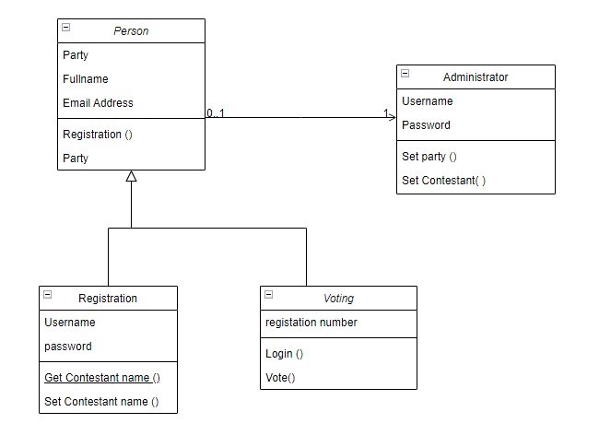
Figure 3.2: Class diagram for the E-MAT system
Activity Diagram:
An activity diagram of the E-MAT project is used to illustrate how the system works from the perspective of different, such as citizens, Election and Party. It shows the steps involved in various scenarios, such as registering, logging in, voting the respective parties, applying for Election, posting representatives of parties, counting the votes etc. It also shows the conditions and decisions that affect the flow of actions, such as validation, verification, authorization, etc.

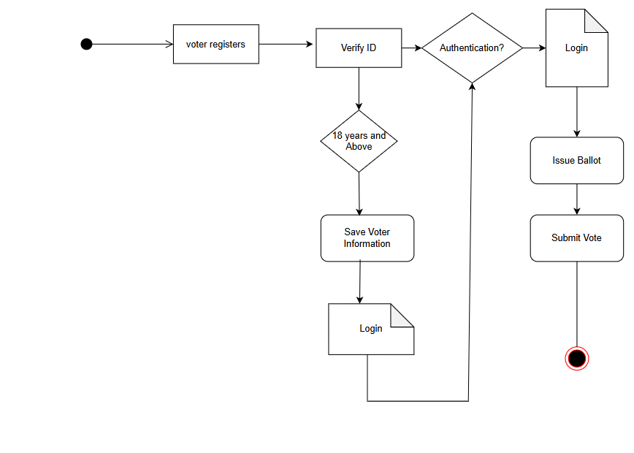
Figure 3.3: Activity diagram for the E MAT system

4.System Design

4.1 Design
The process of designing the project involves conceptualizing the system as well as actually making progressing on finalizing its infrastructure

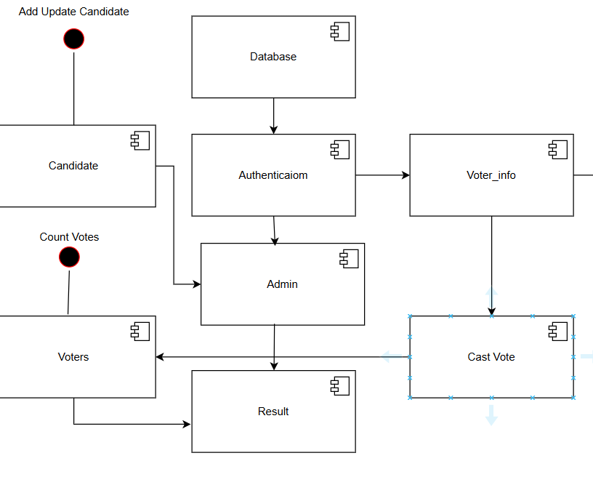
4.1.1 Component Diagram
Figure 4.1: Component diagram of the E-MAT system

The component diagram of system shows how the front end, backend, database, authentication, voting, results, and admin components work together to provide a secure and reliable digital voting system.

4.1.2 State Diagram
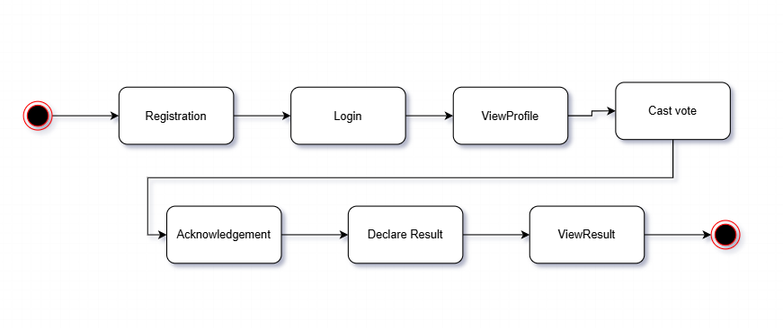
Figure 4.2: State diagram of the E-MAT system
The state diagram of the system begins with the registration process, where a voter or admin enters their details into the system. After registration, the user moves to the login state to verify their credentials. Once logged in, the user can view their profile information. From there, the voter proceeds to the cast vote state, where they select and submit their vote. The system then provides an acknowledgement confirming that the vote has been successfully recorded. After the election is completed, the admin declares the result, and the users can view the result of the election. Finally, the process ends after the result is displayed.

4.1.3 Sequence Diagram
The sequence diagram of the system illustrates the interaction between the admin, candidates, database, system, and voter. First, the admin requests the list of candidates from the database and announces them to the system. Once the voting stage begins, the voter logs into the system, and the system validates the login credentials. After successful validation, the voter casts a vote, which is saved into the database. The system then acknowledges the vote and later announces the voting results. Finally, the admin counts the votes from the database, and the results are declared.

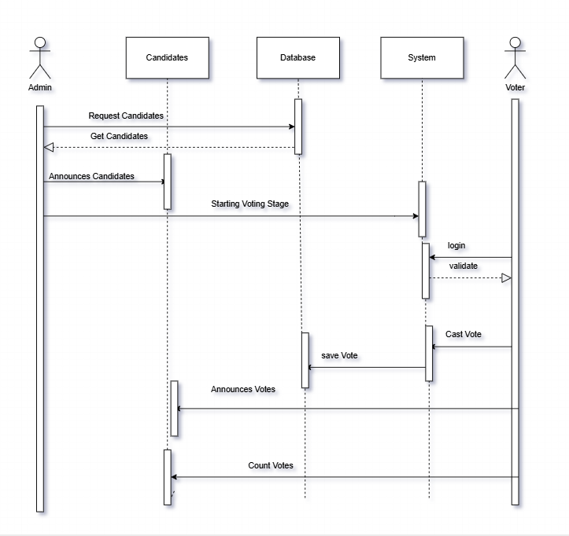
Figure 4.3: Sequence diagram of the E-MAT system

4.1.4 Wireframe Diagram
A wireframe design is a visual representation of the basic layout and structure of a web page, mobile app, or any other software application. It serves as a low-fidelity, skeletal outline of the user interface (UI), focusing on the placement of elements, navigation, and overall structure without including detailed design elements such as colors, images, or fonts.
For the E-MAT Digital Voting System, developed wireframes to outline the user interface for key pages such as the homepage, login page, and voting page are available.
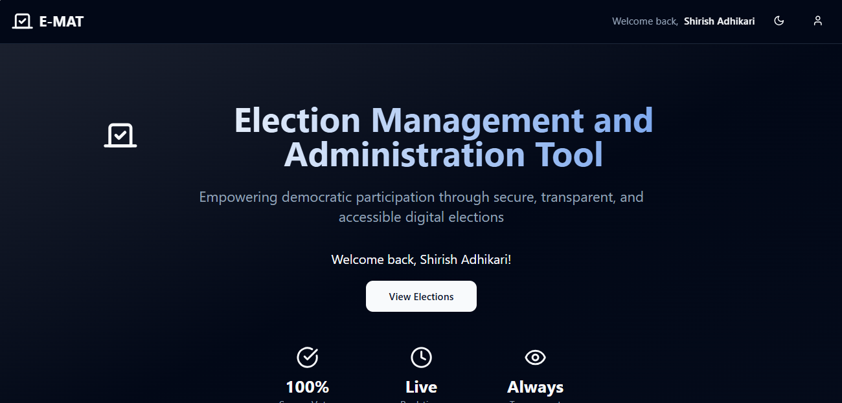
1.Homepage
Figure 4.4: Interface for Homepage

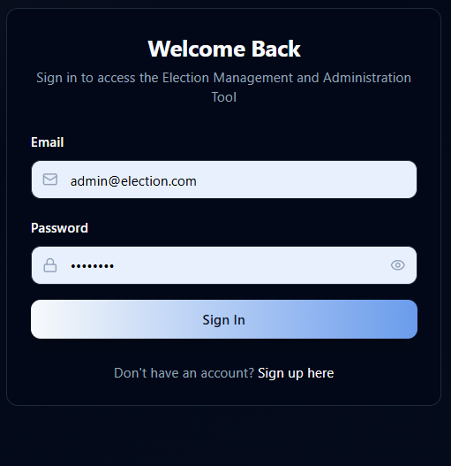
2.Admin Login
Figure 4.5: Interface for Admin Login

3.Voter Register
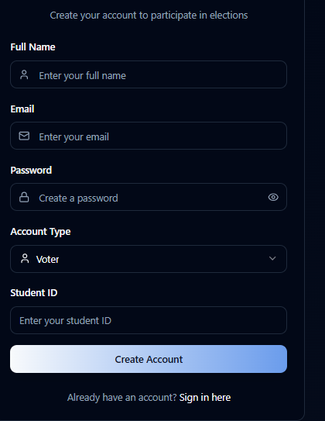
Figure 4.6: Interface for Voter Register
4.Admin Dashboard
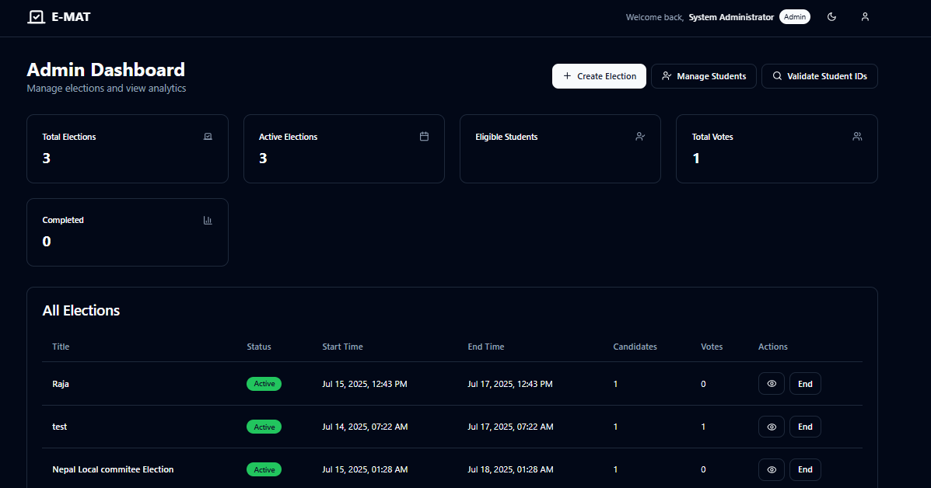
Figure 4.7: Interface for Admin Dashboard

4.2 Description of Algorithms
For the E-MAT project, counting and searching algorithms is used to manage votes and voter data efficiently.
The counting algorithm plays a crucial role in tallying the number of votes each candidate receives. As votes are cast, the system automatically increments the vote count for the selected candidate, ensuring fast and error-free results. This eliminates the need for manual counting and allows real-time result tracking, especially important during large-scale elections. On the other hand, the searching algorithm helps locate specific data within the system, such as finding a voter by their voter ID, searching for a particular candidate, or filtering elections by name or date. Depending on the size of the dataset, either linear or binary search techniques can be applied to ensure quick and accurate access to information. Together, these algorithms enhance the E-MAT system by making it faster, more reliable, and user-friendly for both voters and administrators.[5]
Some python code snippet of the system:
//Counting Algorithms
@router.get("/count")
async def get_students_count(
current_admin = Depends(get_current_admin),
db = Depends(get_database)
):
"""Get total count of students (Admin only)"""
student_service = get_student_service(db)
count = await student_service.get_students_count()
return {"total_students": count}

vote_counts = {}
cursor = self.votes_collection.find({"election_id": election_id})
async for vote:
candidate_id = vote["candidate_id"]
vote_counts[candidate_id] = vote_counts.get(candidate_id, 0) + 1

//counting duplicate and invalid Votes
duplicate_student_votes = []
...
if student_id in student_votes:
duplicate_student_votes.append({...})
...
invalid_student_votes = []
...
if not is_valid:
invalid_student_votes.append({...})

//searching Algorithms
search_filter = {
"$or": [
{"full_name": {"$regex": query, "$options": "i"}},
{"student_id": {"$regex": query, "$options": "i"}},
{"email": {"$regex": query, "$options": "i"}}
]
}
Cursor = self.students_collection.find(search_filter).skip(skip).limit(limit)

//searching for Existing Users
existing_user = await self.users_collection.find_one({"email": user_data.email})
...
existing_student_user = await self.users_collection.find_one({"student_id": user_data.student_id})

Searching for Existing Students by ID or Email
student_data = await self.students_collection.find_one({"_id": student_id})
student_data = await self.students_collection.find_one({"student_id": student_id}

5.Implementation and Testing

5.1 Implementation
The system is implemented using various programming languages and libraries that are open source and well documented.

5.1.1 Implementation Tools
Front End
React with TypeScript: React is used in this system together with TypeScript for front end, to build UI interfaces with datatypes. It is a JavaScript library for building user interfaces.
Tailwind CSS: Tailwind CSS is used in this project for building attractive user interface. It is a utility-first CSS framework that allows you to design modern and responsive user interfaces directly in your markup.
Back End
Fast API: In this project, Fast API handles user authentication via voter ID, vote submission and validation, election, candidate, and voter management, encrypted vote storage and result computation. It is a modern, high-performance web framework for building APIs with Python. It is built on top of Starlette for web handling and Pydantic for data validation.
MongoDB: MongoDB is a NoSQL, document-based database that is used in this system to store voter information, candidate data, vote records, election results.
Version Control
Git/GitHub: GitHub is used in this project for version control system, for tracking changes in source code and collaborative development between teammates.
Drawings
Draw.io: It is used for drawing use cases, activity diagram and class diagram, etc.

5.1.2 Implementation Details of Modules
Modules are the partitions of any project done to ease the task of development. Different modules are designed so that debugging and other development phases get the easiest implementation.
The different modules of the system are:
i) Homepage
Homepage shows basic information about the elections, upcoming timelines, and rules. It also provides options for voters and admins to log in or register.
ii) Registration page
Registration page allows new voters to register using their voter ID and details. If they are already registered, they can simply sign in.
iii) Login page
Login page provides secure access for voters and admins. After logging in, users are redirected to their respective dashboards.
iv) Voter page
Voter page allows voters to view available elections and candidate details. This page also provides the option to securely cast their vote.
v) Admin page
Admin page allows administrators to create and manage elections. It also lets admin add or remove candidates and monitor voter activity.
vi) Create election page
Create election page allows admins to set up new elections. They can define election name, candidates, and the voting timeline.
vii) Result page
Result page displays the election results once voting ends. It shows the total votes for each candidate and the outcome.

5.2 Testing

5.2.1 Test Cases for Unit Testing
Unit testing is a software testing method where individual units or components of a software application are tested in isolation. A unit refers to the smallest testable part of the application. The goal of unit testing is to verify that each unit performs as intended. Unit testing is typically carried out by developers during the development phase.
Below is some test cases used during unit testing in E-MAT project:
Table 5.1: Test case for Admin Login
S. N | Test Inputs | Expected Output | Actual Output | Result
1 | Valid email & password | Login success | Login success and redirected to admin Dashboard | Test Successful
2 | Invalid email or password | Login unsuccessful | Account not found. Please contact the administrator | Test Successful
3 | Empty credentials | Login unsuccessful | Error: Please fill all fields | Test Successful

Table 5.2: Test case for Voter Login
S. N | Test Inputs | Expected Output | Actual Output | Result
1 | Valid Voter ID and password | Login success | Redirect to User Dashboard | Test Successful
2 | Invalid Voter ID or password | Login unsuccessful | Invalid Username and Password | Test Successful
3 | Empty Voter ID and password | Login unsuccessful | Incorrect Password Please try again | Test Successful

Table 5.3: Test case for Casting Vote
S. N | Test Inputs | Expected Output | Actual Output | Result
1 | Valid vote submission | Vote cast successfully | Success message displayed | Test Successful
2 | Trying to vote again | Vote denied | Error: Already voted | Test Successful
3 | No candidate selected | Vote denied | Error: Select a candidate first | Test Successful

5.2.2 Test Cases for System Testing
System testing is conducted after unit testing and integration testing, and it evaluates the system's compliance with specified requirements and its overall functionality. The primary objective of system testing is to ensure that the integrated components of a software application work together as expected and meet the defined requirements. Below are the few test cases for system testing in E-MAT project:
Table 5.4: Test case for Register and Login Workflow
S. N | Test Inputs | Expected Output | Actual Output | Result
1 | New voter registers, logs in, views elections | All steps executed successfully | Successful login and dashboard access | Test Successful

Table 5.5: Test case for Casting Vote and Viewing Result
S. N | Test Inputs | Expected Output | Actual Output | Result
1 | Vote cast and results accessed by admin | Vote counted and result updated | Vote displayed in result summary | Test Successful
Table 5.6: Test case for Admin Election Control
S. N | Test Inputs | Expected Output | Actual Output | Result
1 | Admin creates, edits, and deletes an election | Changes reflected in the database and UI | Success messages shown, election updated | Test Successful

5.3 Result Analysis
The testing results show that E-MAT system is working properly. Both admin and voter features are functioning as expected. The login system is safe and gives clear messages when users enter wrong or missing information.
Voters are able to register, log in, and cast their votes without any errors. The system also prevents voters from voting more than once. Admins can create elections, add candidates, and view results successfully.
All test cases were marked as “Test Successful”, meaning the system responded correctly in every situation. The E-MAT system is ready for real use, offering a smooth and secure experience for both voters and administrators.

6.Conclusion and Future Recommendations

6.1 Conclusion
In conclusion, the E-MAT system has been successfully developed as a secure, user-friendly, and reliable platform for conducting online elections. It addresses the key needs of both administrators and voters by ensuring a smooth and transparent voting experience.
Throughout this project, best practices in system design and development had been employed. Tools like wireframes, use case diagrams, and component diagrams are used to plan and structure the system properly. React with TypeScript, Tailwind CSS is used for the frontend development, and Fast API is used for the backend development which allowed us to build a modern and responsive web application.
Using GitHub as a version control tool helped maintain clear communication during development and working together as a team to solve problems and meet deadlines have helped us stay organized.
After finishing this project, the team has gained invaluable knowledge and skills that remain with us for all our life. This experience has strengthened our skills in software development, teamwork, and project management all of which will be valuable for our future projects.

6.2 Future Recommendation
Some of the Future Recommendation of the project are:
- It will focus on enhancing security, making the platform more user-friendly, and ensuring wider usability across different devices and user groups.
- It will provide better Versions on both computers and mobile devices.
- It will support multiple elections running at the same time, allowing different groups or organizations to conduct their voting processes independently but within the same platform.
- It will provide usability for the use in schools, organizations, and local governments to encourage the adoption of digital voting.
- It will provide fair, safe, and simple elections in Nepal using modern technology.

References
- A. Lapada, “AIRTOR: Evolutionary prototype and its uses,” Indian Journal of Science and Technology, vol. 12, no. 17, May 2019, doi: 10.17485/ijst/2019/v12i17/142868.
- P. Shrestha and R. Gautam, Elector: A Mobile-Based E-Voting Application Using Flutter [Project Report], Apr. 2023. [Online]. Available: https://github.com/prajwolshrestha/Elector. [Accessed: Jun. 2, 2025]
- S Gaire, E-Nirwachan: Biometric Based E-Voting System [Project Report], [Online]. Available: https://github.com/SulavGaire/e-Nirwachan. [Accessed: Jun. 2, 2025]
- Nepal Engineers’ Association, “Election guidelines and use of electronic voting in NEA Elections,” 2023. [Online]. Available: https://nea.org.np/e-voting-guideline. [Accessed: Jun. 2, 2025].
- T. Smith, “Frequency counters 101: The algorithm pattern you need to know,” TeddySmith.IO, Dec. 30, 2024. [Online]. Available: https://teddysmith.io/frequency-counters-algorithm-pattern/. [Accessed: Jun. 2, 2025].

Appendix
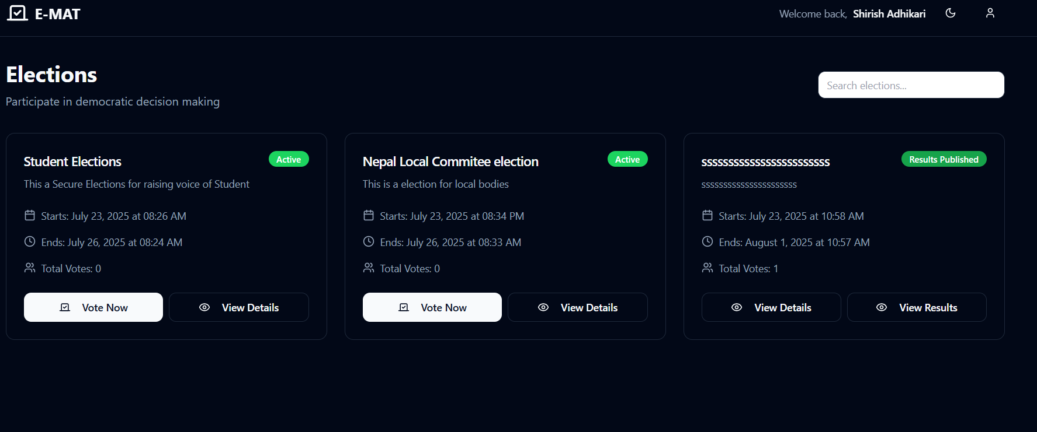
Screenshot of Election page

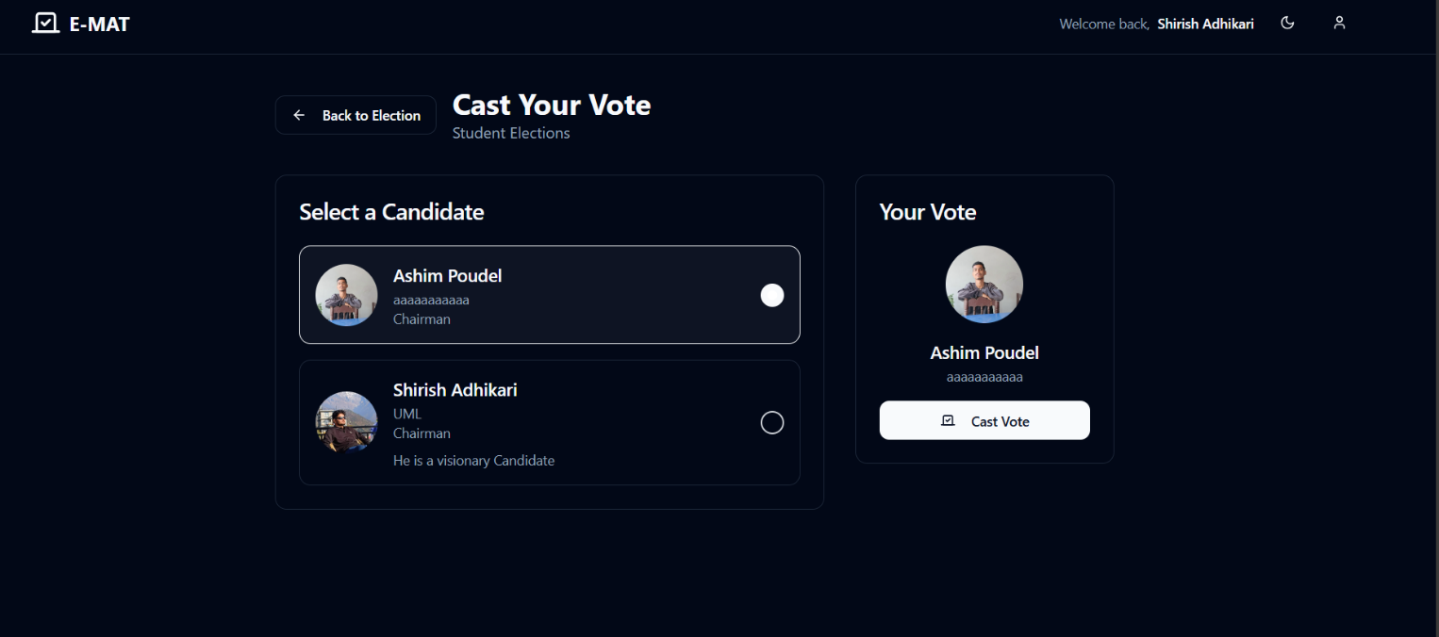

Screenshot of vote casting process

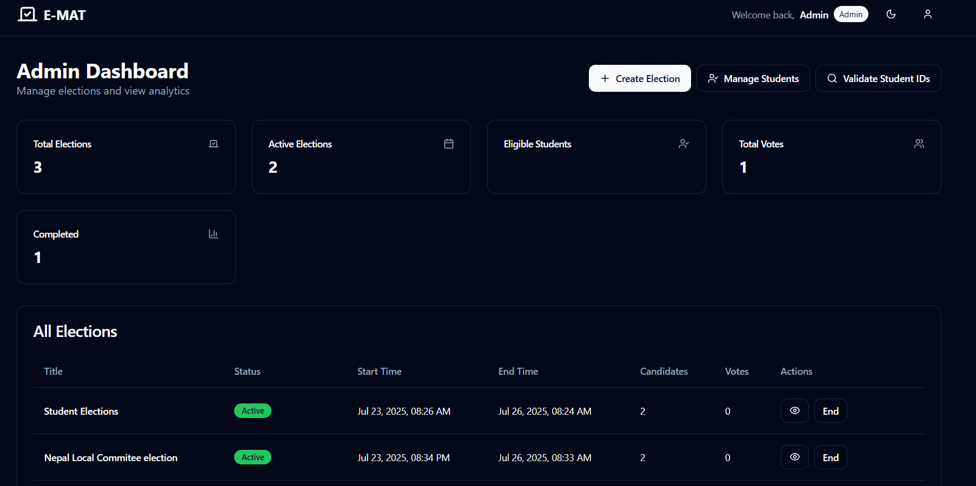
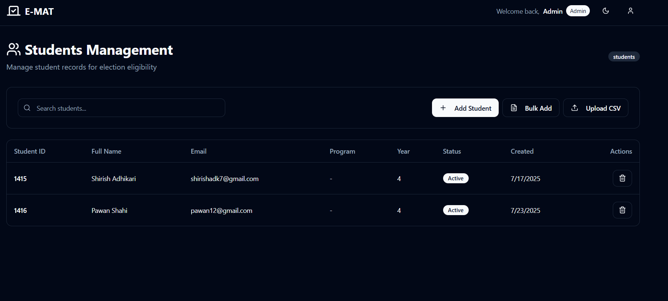

Screenshot of Admin Dashboard
Screenshot of Student Management page
Fig: Result Page

Fig: Result Page

Fig: Result Page

Fig: Result Page

